**Project Title: Anomaly Detection in Credit Card Fraud**

**Scope of the project:**

Aiming to implement anomaly detection techniques for identifying fraudulent transactions within credit card data. Objectives include preventing financial losses and ensuring customer security by promptly detecting anomalous behaviour in credit card transactions.

**Data set:**

**Source:** The dataset comprises credit card transactions collected from financial institutions.

**Details:** Contains 284,807 samples and 31 features.

**Features**: Includes transaction amount, time, and other anonymized numerical features.

**Solution:**

**Approach**: Employed Isolation Forest, Local Outlier Factor, and One-Class SVM for anomaly detection.

**Preprocessing:** Standardization of 'Amount' and 'Time' features using StandardScaler.

Model Selection: Utilized Logistic Regression, Decision Tree, and Random Forest classifiers for fraud prediction.

**Output:**

Detects potentially fraudulent transactions using anomaly detection algorithms.

Identifies outliers and anomalies in credit card transactions to alert financial institutions.

**Snapshot:**

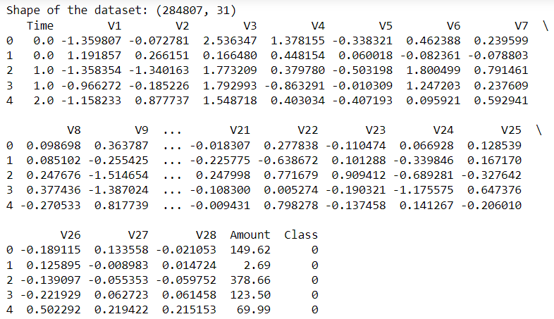

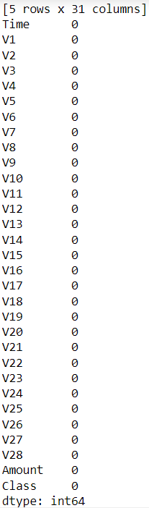 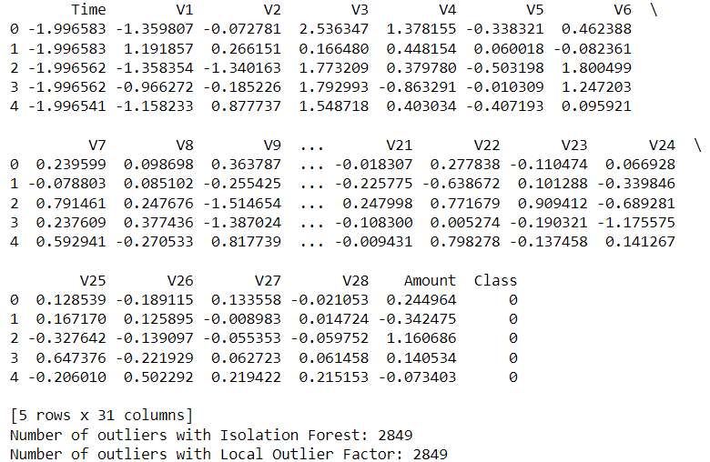

**Accuracy:**

**Metrics varied for different models:**

**Isolation Forest:** Detected 492 fraudulent cases out of 284,315 transactions.

**Local Outlier Factor:** Detected a similar number of fraudulent cases as Isolation Forest.

**One-Class SVM:** Identified 473 fraudulent cases out of 284,315 transactions.

**Conclusion:**

Demonstrates the efficacy of anomaly detection algorithms in identifying potential credit card fraud. Benefits include timely fraud detection, preventing financial losses, and ensuring customer trust. Future scope involves improving models for better accuracy and real-time implementation in financial systems.